Title in Bold Font Size 9, Times New Roman

Student Name and Supervisor Name * (without any title)

School of Mechanical Engineering, Faculty of Engineering,
Universiti Teknologi Malaysia, 81310 UTM Johor Bahru, Johor, Malaysia.
*Corresponding author: email@mail.fkm.utm.my

ABSTRACT
An abstract is an important overall summary of the paper. It should be written in italic using Times New Roman (TNR) and font size, 9 pt. As a guide, it should comprise of about 150 words and be as concise and precise as possible. The layout for this section should be justified/aligned at both left and right margins. The abstract should not only describe the rationale, aim and scope of paper but also provides a glimpse of the methodology and important results/outcomes of the undertaken research/study. Citation should not be given at all in this section.

INTRODUCTION
The first sentence in the following paragraph should be indented at 0.5 cm. No spaces are to be left between the paragraphs. Lines of text should cover the entire page length. Do not begin a new section directly at the bottom of a page as it is preferable to transfer the heading to the top of next page.
The references should be cited consecutively using “Name and year” style. Please use APA format (Hasbullah, 2018). All the cited references should be listed at the end of the paper and must match with the appropriate and sufficient description of the citations in the main text.

METHODOLOGY
Tables and figures should be arranged logically and sequentially numbered throughout the text and they should be first mentioned in the text on the same page before they are presented.
The captions should be as brief as possible but are sufficiently/accurately described. For the table, the caption should be placed at the top center of the table while for the figure, it should be placed below it, also at the center.
The first sentence in each sub-section should be written in bold, numbered sequentially, should not be indented and only the first letter of the word is capitalized. All tables should be kept simple and precise and must be referred to in the text. Tables should be presented in the form as shown in Figure 1 with a single line spacing before and after them. The table should be constructed to show the horizontal lines (1 pt. line width) without any vertical lines. The first row of the table describing the topics should be written in bold, TNR, 9 pt.
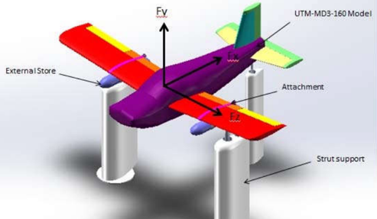
Figure 1: Experimental rig for light aeroplane in 3-axis gauge sensor.

RESULTS AND DISCUSSION
All figures submitted should be of high quality and presented in black and white or color prints with or without border. Explanations and lengthy description should be placed in the text rather than within the figures, i.e., the captions should be short and precise. All figures / illustrations / graphics should be formatted as ‘In line with text’ with no text wrappings, as shown in Figure 2.
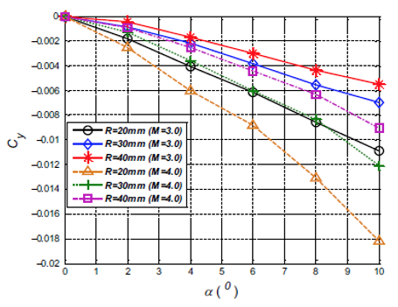
Figure 2: Value of C_{y} vs angle of attack.

CONCLUSION
It should be brief and clearly summarizes the main outcomes/results of the undertaken study/research. It may include a few recommendations for future works.

REFERENCE
Author, O., Author, T & Author, T. (2003). Paper title. Journal Name, Volume, page number.
Lazim, T. M., Mat, S., & Saint, H. Y. (2003). Computational fluid dynamic simulation (CFD) and experimental study on wing-external store aerodynamic interference of a subsonic fighter aircraft. Acta Polytechnica, 43(5).

