TITLE……
(FONT - TIMES NEW ROMAN; SIZE – 16; STYLE – BOLD & UPPERCASE)
(MAXIMUM 3 PAGES)

T. Author 1^{1,2}*, M. Author 2^{1, 2}, E. Author 3³

¹Laboratory of Biocomposite Technology, Institute of Tropical Forestry and Forest Products, Universiti Putra Malaysia, 43400 UPM Serdang, Selangor, Malaysia
²Department of Mechanical and Manufacturing Engineering, Universiti Putra Malaysia, 432400 UPM Serdang, Selangor, Malaysia
³Department of Aerospace Engineering, Universiti Putra Malaysia, 43400 UPM Serdang, Selangor, Malaysia

[All body text must use Font Type: Times New Roman; Size: 9; Style: Bold (Heading line) and Regular (text content) Paragraph Alignment: Justified; Line spacing: Single]

ABSTRACT

The growing environmental devastation ascribed to the disposal of packaging plastic waste has led to an urgent need to develop environmentally friendly packaging materials to rescue our ecosystem. In an effort to resolve the ongoing environmental crisis caused by non-biodegradable plastics, natural biopolymers have been considered as potential alternatives to conventional plastics. Biodegradable films for packaging have been reported to have low water barrier resistance. Such drawback strongly limit their wide application, especially for food packaging purposes. Many studies have been undertaken by scientists to improve the water sensitivity of starch-based materials without compromising their biodegradability. The reinforcement of natural biopolymers with nanocellulose has been shown to be beneficial for water transmission properties of biodegradable film.

Keywords: water barrier, biodegradable films, nanocellulose, food application.

INTRODUCTION

Common materials used for food packaging are plastics, paper and metal. However, the utilization of plastic overshadows metal and paper due to their low cost production and outstanding material properties. To date, almost one-third of the world’s non-degradable plastic production is used in packaging application. This large volume of food packaging is meant to be quickly discarded, and the waste volume has not been greatly reduced by the recycling programs, because of high recycling costs and difficulties related to polymer separation [1]. Several biodegradable films to be used in food packaging, not to completely replace synthetic plastics, but rather to improve their efficiency, thus reducing the amount of synthetic polymers required for each application. Food packaging is essential to avoid deterioration of food products during handling and storage, besides provide nutritional information and expired date of the products.

________________________________
Article history:
Received: 1 April 2022
Accepted: 2 June 2022
Published: 22 August 2022
_______________

E-mail addresses:
ahmadilyasrushdan@utm.com (R.A. Ilyas)
sapuan@upm.edu.my (S.M. Sapuan)
mohdridzwan@upm.edu.my (M.R. Ishak)
*Corresponding Author

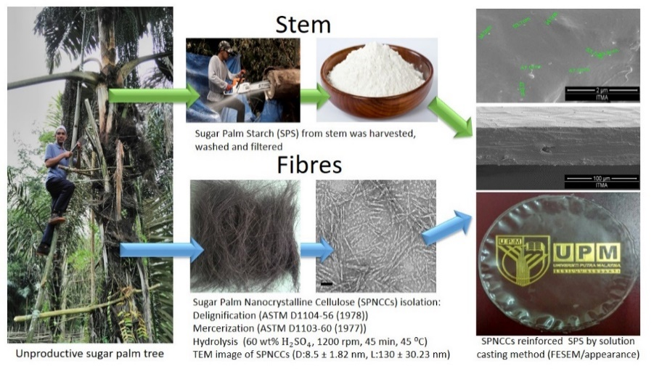
Fig. 1: Biodegradable film from sugar palm tree [1]

TABLE 1: Water permeability properties of biodegradable films reinforced with nanocellulose for food packaging application

Authors | Polymer | Source of nanocellulose | Description
Ilyas et al., [1] | Sugar palm starch | Sugar palm fibre | - Increasing the SPNCCs concentration from 0.1% to 1.0% caused a slight reduction in the WVP of composite films.
*Commercial crystalline microcellulose (MCC), cellulose nanofibre (CNF), microfibrillated film (MFC), cellulose nanocrystals (CNC), water vapour permeability (WVP), polyvinyl alcohol (PVA)

MATERIALS AND METHODS

Materials
Sugar palm fibres gathered in Bahau (Negeri Sembilan, Malaysia) were used in this study. The chemical reagents used were sodium chlorite, acetic acid, sodium hydroxide and sulphuric acid (purchased from Sigma–Aldrich).

Methods
The fibres were grinded and sieved.

RESULTS AND DISCUSSION

Subsection 1
The chemical compositions of the sugar palm fibres were affected by the chemical extraction process, NaClO₂ followed by NaOH.

Subsection 2
The mechanical performances of the films were monitored in term of tensile strength, Young’s modulus and elongation at break.

CONCLUSIONS

Water vapor barrier properties of biodegradable films were improved by addition of cellulose nanofibers.

ACKNOWLEDGEMENTS

The authors would like to thank Universiti Putra Malaysia and Ministry of Education, Malaysia for the financial support through the Graduate Research Fellowship (GRF) scholarship, Universiti Putra Malaysia Grant scheme Hi-CoE (6369107) and FRGS/1/2017/TK05/UPM/01/1 (5540048).

REFERENCES

[1] R. A. Ilyas, S. M. Sapuan, M. R. Ishak, and E. S. Zainudin, “Development and characterization of sugar palm nanocrystalline cellulose reinforced sugar palm starch bionanocomposites,” Carbohydr. Polym., vol. 202, pp. 186–202, Dec. 2018, doi: 10.1016/j.carbpol.2018.09.002.

(IEEE; Times New Roman; Size 9; spacing single; Justify)

